Suspension report of Aghorekamini Prakashchandra Mahavidyalaya

Name of the Suspended Employee | Name of the Office/Institution with address | Suspended from | Reason for suspension | Any other details
NA | Aghorekamini Prakashchandra Mahavidyalaya  Subhasnagar, Bengai, Hooghly, 712611 | NA | NA | NA



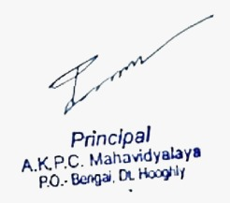

PRINCIPAL
(DR. PARAMARTHA GHOSH)

